**Maven** is like a super organized librarian for computer programs. It helps software developers manage their projects and the libraries or pieces of code they need to build their software. Imagine you're building a house, and you need various tools and materials like bricks, wood, and nails. Maven is like the person who keeps track of what tools and materials you need, where to get them, and how to use them properly to build your house (or software, in this case).

Now, let's talk about **Maven plugins**. These are like special helpers that Maven calls upon when it needs to do specific tasks. Think of them as skilled workers with their own tools who come in to help you with specific parts of building your house (or software). For example:

1. **Compile Plugin**: This is like a carpenter's tool that turns your written code into a form that the computer can understand and run. It takes your code and makes sure it's ready to be used.
2. **Package Plugin**: Think of this as a box-making machine. It takes all your code and puts it neatly into a box (like a ZIP file or a JAR file), making it easier to distribute and use.
3. **Testing Plugin**: Imagine you have a team of people who check every room in your house to make sure it's built correctly. This plugin does the same thing but for your software. It tests your software to make sure it works as expected.
4. **Deploy Plugin**: This is like a delivery service. It takes the packaged software and sends it to the right place, like a server or a website, so that others can use it.

So, in a nutshell, Maven is like your project manager and organizer for building software, and Maven plugins are like specialized tools or workers that help with specific tasks along the way. They make sure everything is in order and ready for your software to be used by others.

**Maven** is like a helpful assistant for software developers. Imagine you're building a complex structure, like a house made of Lego bricks. You have different types of bricks, like red, blue, and green, and you need a way to put them together in the right order to build your house.

Maven is like the instruction manual and manager for your Lego house project. It helps you:

1. **Organize your bricks:** Maven helps you keep your project organized by separating different types of bricks (code and resources) into neat folders and making sure they are in the right place.
2. **Get the right bricks:** Maven knows where to find the specific Lego bricks (dependencies or libraries) you need for your project. It fetches them from a big Lego storage room on the internet, so you don't have to search for them yourself.
3. **Put the bricks together:** Maven tells you how to assemble your Lego house step by step. It defines the order in which your code should be built and how different parts fit together.

Now, let's talk about **plugins**:

Think of plugins as special tools or machines you can add to your Lego project to make it even cooler. For example:

* If you want to paint your Lego house a different color, you can use a "Painting Plugin" that knows how to change the color of your Lego bricks.
* If you want to add lights to your Lego house, you can use a "Lighting Plugin" that knows how to install and control the lights.

In the world of software development, plugins are like extra helpers that you can add to Maven to perform specific tasks in your project. These tasks can be things like compiling your code, running tests, creating documentation, or even deploying your software to a server.

So, in a nutshell, Maven is like an organized project manager for your software development, and plugins are like specialized tools you can use to add extra functionality to your project. They work together to make building software easier and more efficient, just like using instructions and tools to build a Lego house.

Summary

Learn the basics of Apache Maven in this introductory tutorial.

Highlights

📚 Explore the fundamental concepts of Apache Maven.

🛠️ Understand how Maven simplifies project management and build processes.

🧰 Learn about the central repository and dependency management.

📦 Discover how to create a Maven project and its directory structure.

🔄 Gain insights into the Maven build lifecycle and phases.

📜 Get familiar with the POM (Project Object Model) and its significance.

🚀 Start your journey into efficient software development with Apache Maven.

To learn about Apache Maven, which is a tool that helps make managing software projects easier. We'll cover how to set up a Maven project, how to organize project files, how Maven builds your project, and how to configure project settings using a file called "pom.xml."

Highlights

* 🧰 **What is Apache Maven?**: Imagine you're building a puzzle, and each piece of the puzzle is a part of your software project. Maven is like a special toolbox that helps you organize these puzzle pieces and put them together more efficiently.
* 📁 **Project Folder Structure**: Just like how you keep your school books separate from your toys, Maven helps you keep different parts of your project in specific folders. This makes it easier to find what you need when working on your project.
* 🔄 **Maven Build Process**: Think of building a project like baking a cake. Maven follows a set of instructions (build life cycle) to turn your project pieces into a finished product. Each step in this process has a specific job, like mixing ingredients in the right order.
* ⚙️ **pom.xml Configuration**: The "pom.xml" file is like a recipe card for your project. It tells Maven what ingredients (libraries and tools) your project needs and how to put everything together. You can think of it as your project's instruction manual.

So, Apache Maven is your handy project management assistant that helps you keep things organized, follows a recipe to build your project, and ensures you have all the ingredients you need.

**Summary**

In this Part of the Apache Maven Tutorial, we explore maven project folder structure, the Maven build lifecycle, and the importance of the pom.xml file.

Highlights

📁 Understand the Maven project's folder structure and how it organizes your project's resources.

⚙️ Explore the Maven build lifecycle and its phases, from clean and validate to deploy.

📋 Learn about the crucial role of the pom.xml file in defining project dependencies and configurations.

**Apache Maven Surefire plugin:**

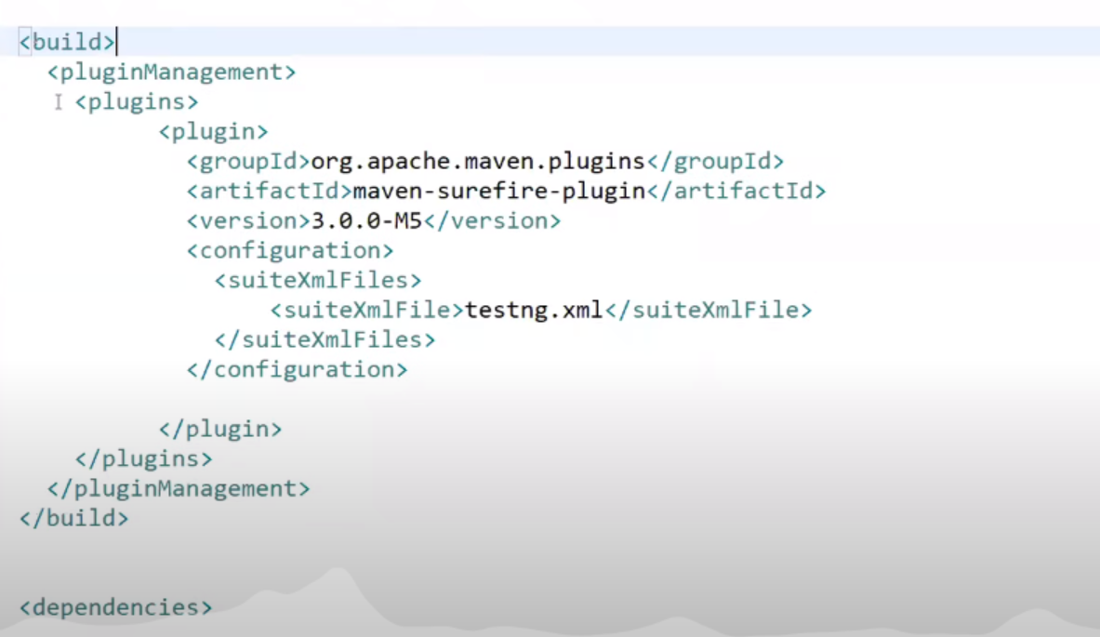

**Explanation -1**

Surefire is a popular plugin in the Maven build tool ecosystem, and it's a handy tool for running tests in your Java projects. Let's break down what the Surefire plugin does in simple terms, provide examples, and explain its significance.

**What does the Maven Surefire plugin do?**

Maven Surefire plugin helps you run automated tests for your Java code. It's like having a robot that checks if your software is working correctly by running predefined tests you've written. These tests can verify that your code does what it's supposed to do and that it hasn't broken anything when you make changes.

**Why is it important?**

Imagine you're building a complex software application with hundreds or thousands of code files. As you make changes or add new features, you might accidentally introduce bugs or errors. The Surefire plugin helps catch these issues early by running your tests automatically whenever you build your project. If any test fails, it alerts you, allowing you to fix the problem before it becomes a bigger issue.

**How to use Maven Surefire plugin with examples:**

1. **Add Surefire plugin to your Maven project:**

In your project's `pom.xml` file (Maven's configuration file), you specify the Surefire plugin:

```xml

<build>

<plugins>

<plugin>

<groupId>org.apache.maven.plugins</groupId>

<artifactId>maven-surefire-plugin</artifactId>

<version>3.0.0</version>

</plugin>

</plugins>

</build>

```

This tells Maven to use the Surefire plugin when you run tests.

2. **Write and organize your tests:**

You create Java classes that contain your tests. These classes typically have names ending with `Test`. For example:

```java

public class CalculatorTest {

@Test

public void testAddition() {

Calculator calculator = new Calculator();

int result = calculator.add(2, 3);

assertEquals(5, result);

}

}

```

In this example, `CalculatorTest` is a test class with a single test method `testAddition`. It checks if the `add` method of the `Calculator` class correctly adds two numbers.

3. **Run your tests:**

Use the following Maven command in your project's directory to run the tests:

```

mvn test

```

Maven will execute all the tests in your project using the Surefire plugin. If any test fails, it will display an error message, helping you identify and fix the issue.

That's the Maven Surefire plugin in action! It simplifies the process of testing your Java code, ensuring that it functions correctly and stays reliable as you make changes and improvements to your software.

**Explanation -2**

Surefire Plugin is a tool in the Java world that helps developers test their code. It's like having a robot that checks if your code works as expected. Let's break down what the Surefire Plugin does, how it works, and provide some simple Java examples.

What Surefire Plugin Does:

Surefire Plugin allows you to run your Java tests automatically. Tests are like little experiments you write to make sure your code does what it's supposed to do. The plugin takes your tests and runs them quickly to see if everything's working fine.

How Surefire Plugin Works:

Imagine you have a folder with a bunch of Java test files. You want to check if your code in those files works as intended. Surefire Plugin steps in:

It finds all your test files.

It compiles (translates) your Java code and your test code into a form that the computer can understand.

It runs your tests one by one, like a teacher checking each student's work.

It tells you if your tests passed (everything is good) or failed (something's wrong).

Examples with Java:

Let's say you have a simple Java program with a class called Calculator that can add numbers. You want to make sure it works, so you write some tests.

Here's your Calculator class:

java

Copy code

public class Calculator {

public int add(int a, int b) {

return a + b;

}

}

Now, you write tests using a testing framework like JUnit. You create a test class like this:

java

Copy code

import org.junit.jupiter.api.Test;

import static org.junit.jupiter.api.Assertions.*;

public class CalculatorTest {

@Test

public void testAdd() {

Calculator calculator = new Calculator();

int result = calculator.add(2, 3);

assertEquals(5, result); // This checks if 2 + 3 equals 5.

}

}

To use Surefire Plugin, you configure it in your project's build configuration file (typically pom.xml for Maven projects). Here's a simplified example:

xml

Copy code

<build>

<plugins>

<plugin>

<groupId>org.apache.maven.plugins</groupId>

<artifactId>maven-surefire-plugin</artifactId>

<version>3.0.0</version>

<configuration>

<includes>

<include>**/CalculatorTest.java</include>

</includes>

</configuration>

</plugin>

</plugins>

</build>

Now, when you run mvn test in your project folder, Surefire Plugin will find and run your CalculatorTest class, and it will tell you if your Calculator code is working correctly.

If everything's good, you'll see a message like "Tests run: 1, Failures: 0, Errors: 0" in the command line, which means your tests passed.

In simple terms, the Maven Surefire Plugin helps you automate the process of running tests in your Java project to ensure your code behaves as expected, just like a robot checking your work to make sure it's correct.